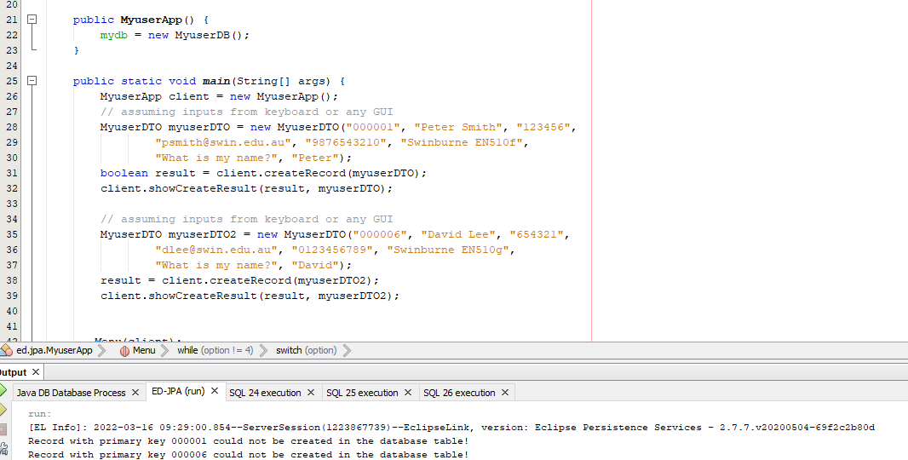Step 1 ending part:

Step 2 all parts:

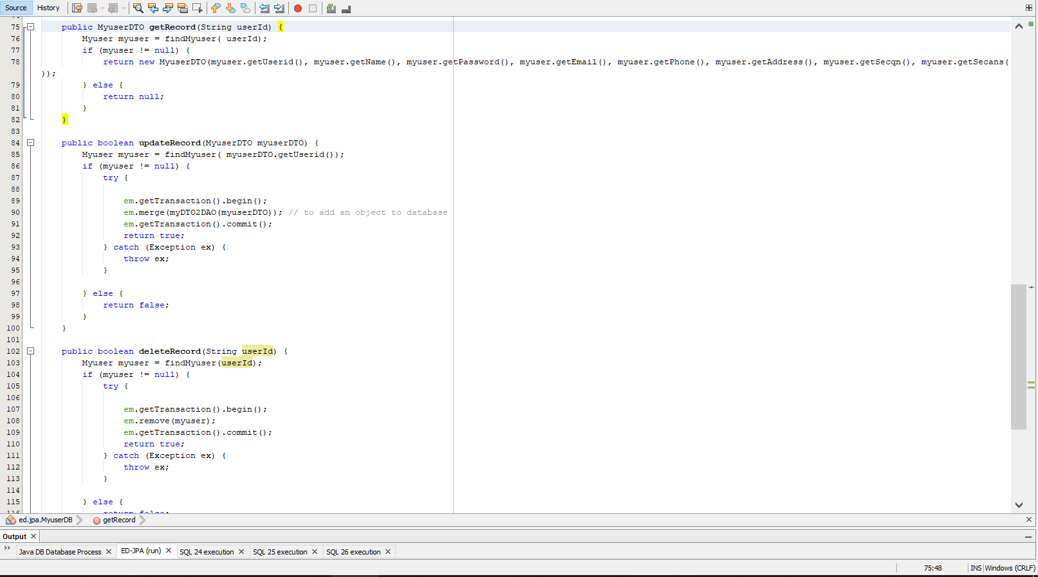

Step 3 all code parts:

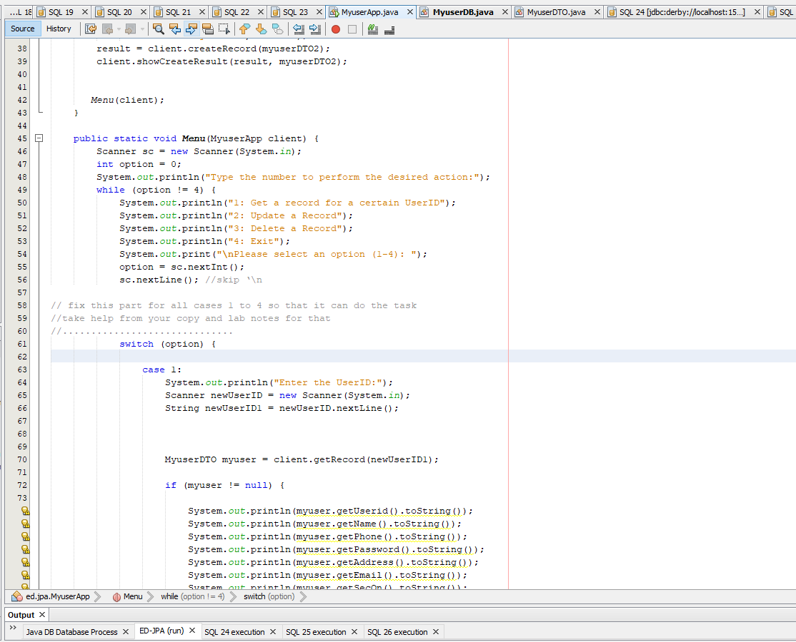

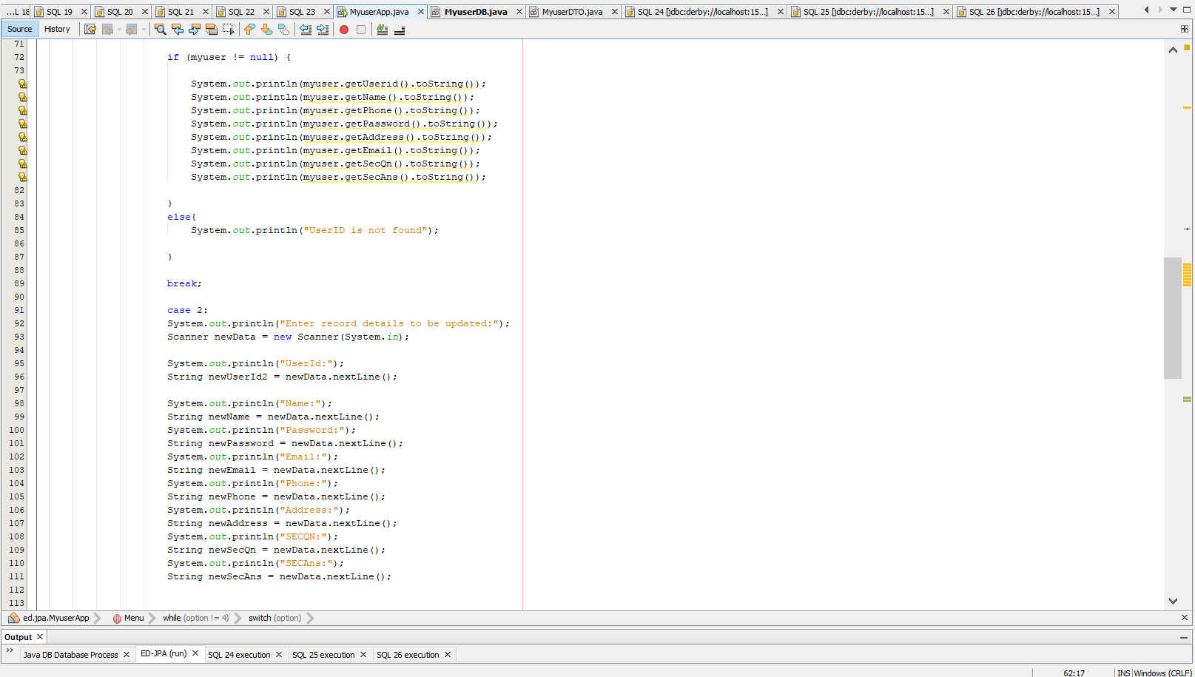

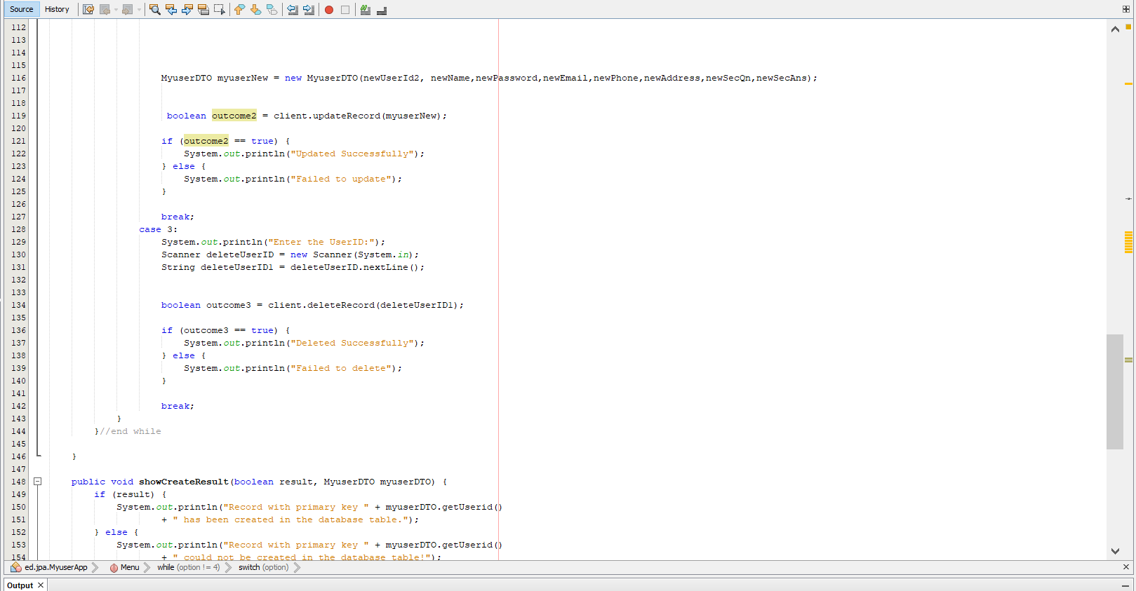

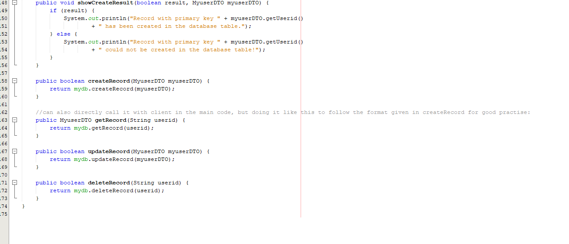

Step 3 outputs:

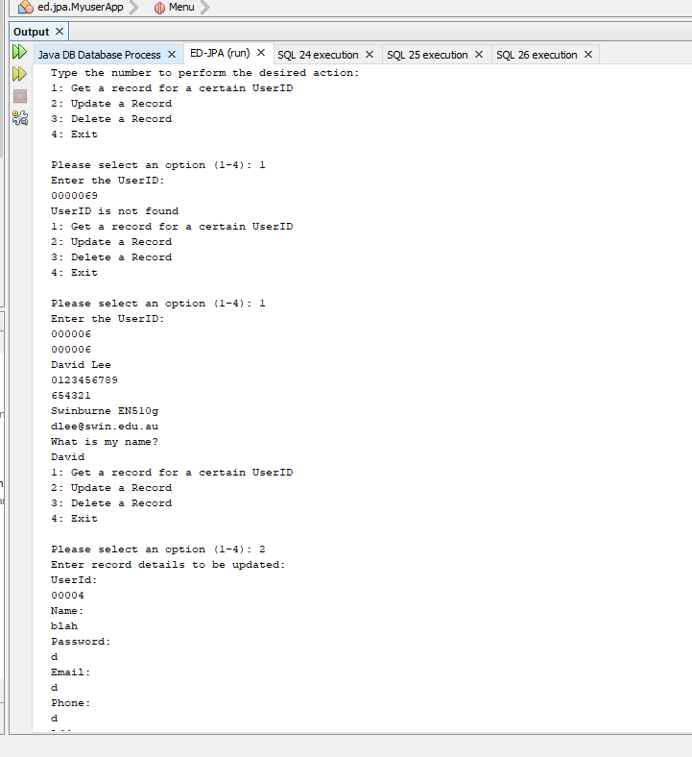

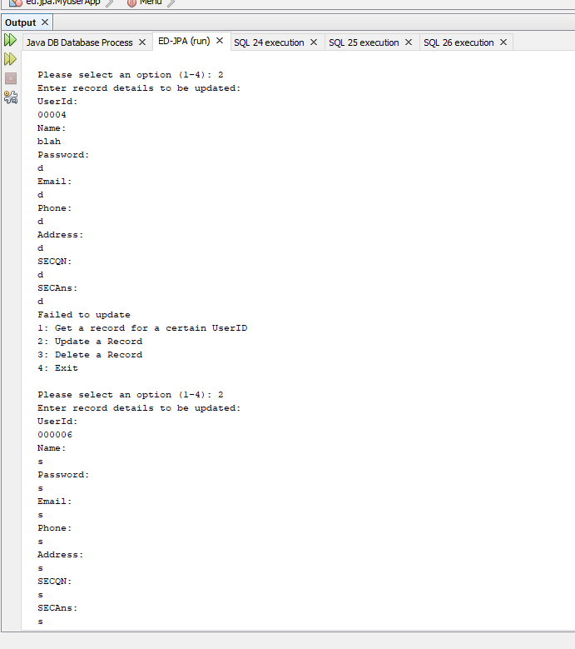

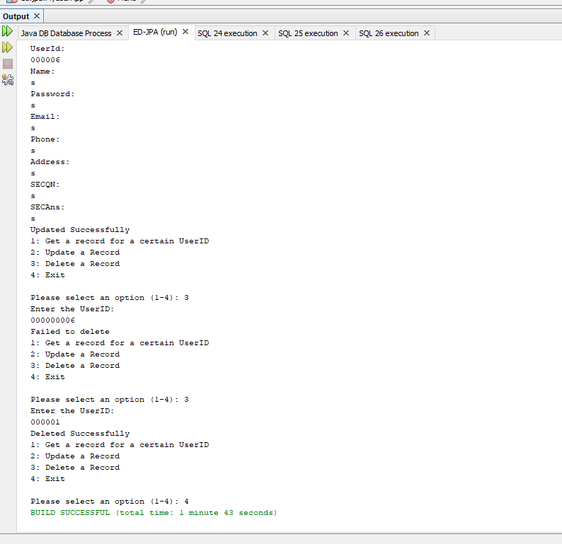

4.1) Here myuser is the DAO object and thus is the one directly accessing the database when the object is created. So it is responsible for the ORM work

4.2) Yes because here it is working as the DAO while there it was working as the DTO

4.3) Previously it was a single, stand-alone java file that was a DTO, but now its just an object located inside the myuserDB and acting as the DAO.